Software and Package(CMD)
- Python3:
- Pycharm:
- Package needed:
Numpy, Scipy, Scrapy, BeautifulSoup, nltk, genism
Procedure to install package
- Cd to directory in which your python installed:
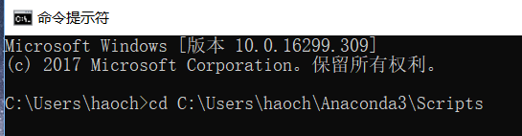
- Install package you want (e.g, pip3 install nltk)
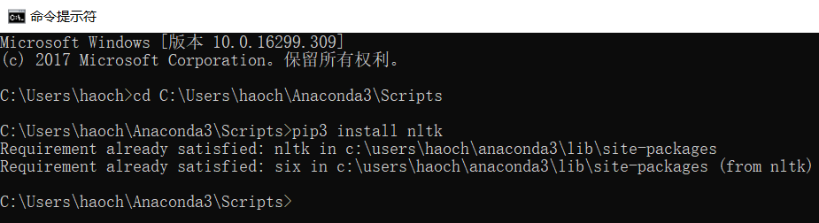

Crawl web text from OSHA website(file: Crawl_cases_from_OSHA)
- When everything prepared, please open CMD command and cd to dictionary of “Crawl_cases_from_OSHA”
- Then, run following code : scrapy crawl construction
- You need to type into keyword you want to crawl:
(your keyword must be coincide with keyword list on OSHA website: full list of keyword in OSHA is here)
(Date from : 1981.1.1 – 2017.12.31)
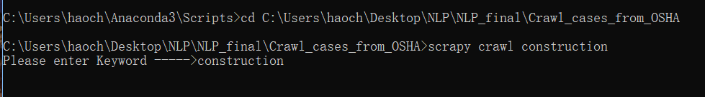
Input: scrapy crawl construction, keyword
Output: keyword.txt file
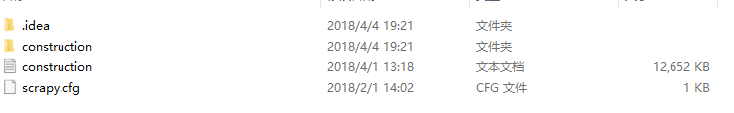

Collect and process dataset(file: Combination.py)
- Collected data source: (all dataset should put into dataset file)
- OSHA data: we have crawled in part 2(12MB)
- Construction dataset: Public dataset for construction(69MB).
(Tixier, Antoine J-P., Michalis Vazirgiannis, and Matthew R. Hallowell. "Word Embeddings for the Construction Domain." arXiv preprint arXiv:1610.09333 (2016))
- Process data:
Combine above 2 dataset into 1 dataset

Input:run this code by right click and “run ‘combination’”, enter keywords you have used in part 2
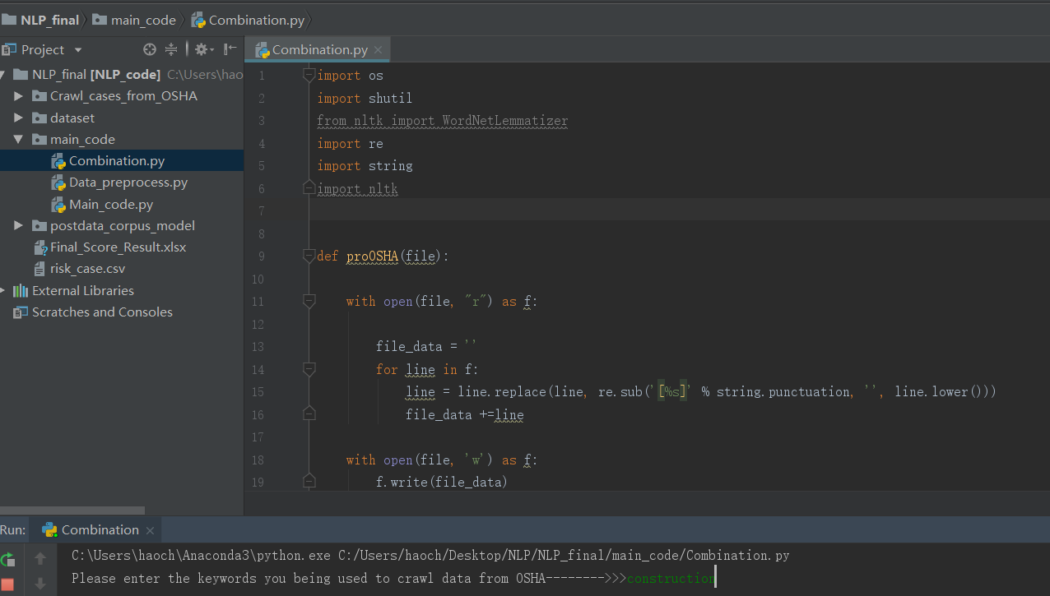

Output: final_data.txt
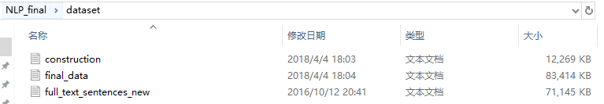

Train Word2Vec model(Data_preprocess.py)
4.1 Function:
Part1: Risk case processing
- Convert risk case from text to csv file
- Run preprocess function with English stopwords
- Find top 200 frequency words and manually select meaningless stopwords
- Find words that appear less than 2 times
- Add 4.3 and 4.4 and English stopwords into one file named ‘overall_case_stopwords’
- Run preprocess function with overall stopwords
- Build up dictionary and corpus and save to postdata_corpus_model

Part2: Keyword pre-process and train Word2Vec model:
- Import dictionary and corpus
- Process keywords: from following paper
(Zou, Yang, Arto Kiviniemi, and Stephen W. Jones. "Developing a tailored RBS linking to BIM for risk management of bridge projects." Engineering, Construction and Architectural Management 23.6 (2016): 727-750.)
Part3: expand keyword using Word2Vec model:
For each keywords in list, expand it’s top 10 words using word2vec model

  - How to run ‘Data_preprocess.py’?
Input: right click in Data_process.py and run ‘Data_preprocess.py’
- Input the keywords you have used in part2
- You must create a file named ‘manually_selected_stopwords’ and input ‘yes’ to continue run code.
- You can add more construction/safety-related keywords into pre_keyword.txt file and input ‘yes’ to continue run code.
- Before training model, there will be a notify, input yes if you have prepared
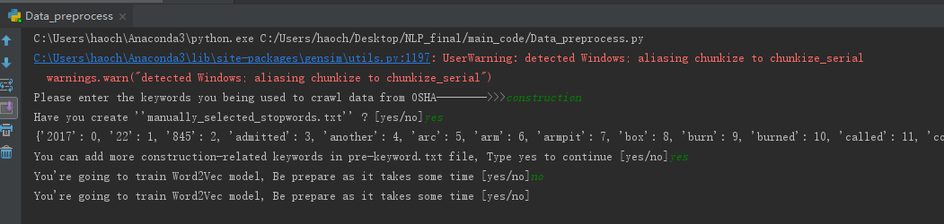

Output: All output is in here:
- dictionary_corpus: Store computed risk case dictionary and corpus
- keywords: Store raw_keywords, pre_keywords, keywords_lexicon.csv
- post_data: Store kinds of stopwords and overall_stopwords
- trained_model: Store trained Word2Vec model
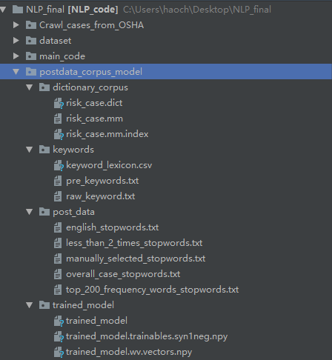

Query Processing(Main_code.py)
5.1 Function of part5:
- Process query
- Expand query
- Compute TF-IDF score for original query
- Compute TF-IDF score for expand query
- Combine above two score with weights
- Computer final similarity and export as CSV file

  - How to run Main_code.py:
Input: right click in run Main_code.py and run ‘run Main_code.py’
- Enter a query and press Enter;
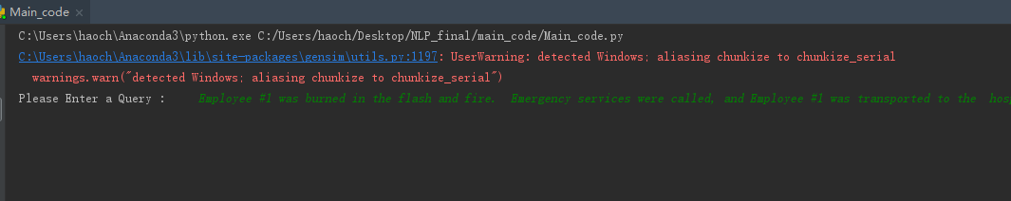
Output: Final_Score_Result.xlsx
- Case index: document index
- Similarity: between query and cases
- Case description: case information
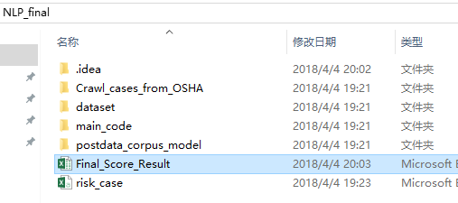
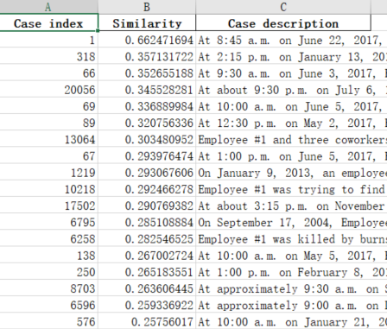
- Reference paper:
[1]. Tixier, Antoine J-P., Michalis Vazirgiannis, and Matthew R. Hallowell. "Word Embeddings for the Construction Domain." arXiv preprint arXiv:1610.09333 (2016)
[2]. Zou, Yang, Arto Kiviniemi, and Stephen W. Jones. "Retrieving similar cases for construction project risk management using Natural Language Processing techniques." Automation in Construction 80 (2017): 66-76.
[3]. Zou, Yang, Arto Kiviniemi, and Stephen W. Jones. "Developing a tailored RBS linking to BIM for risk management of bridge projects." Engineering, Construction and Architectural Management 23.6 (2016): 727-750.

Overall Structure
